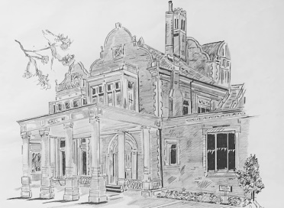

Uffculme Centre

Hello,

Many thanks for your wedding enquiry.

The centre holds a civil wedding licence and the details regarding room cost and capacity are outlined below.

The Uffculme Centre can accommodate you for either a civil ceremony or a wedding breakfast or you can have both within the centre.
Our Lower Conservatory is available for a civil ceremony, which seats 90 guests and costs £500.00.

The Main Hall can be used for your wedding breakfast with a maximum seated of 100 guests with an extra 80 for the evening and incurs a room hire charge of £1500. This covers an 8 hour hire of the Main Hall on the Saturday up until 00:00 and an allowance of 2 hours for table/personal decoration of the Main Hall on the Friday between 16:00-18:00.

Additional hourly rate in excess of the 10 hours (2 hrs Friday set up & 8 hrs Saturday) is £150.00 (this does not relate to any bar extension)

White chair covers can be hired for £1.50 each.

The bar closes at 11.00pm with 30 minutes drinking up time and the wedding party and guests must have left the building by midnight.

Included in the price:
- All table linen and napkins
- Crockery, cutlery and glassware
- PA system and microphones
- Cake stand and knife
- Five uplighters set up in the main hall

Wedding Breakfast
For the wedding breakfast we have a selection of menus from canapés, to evening buffet. Prices for a sit down 3 course meal start from £35.00 per head and must consist of at least 50 guests. We also have various drinks packages to choose from.

Wedding Party
If you are looking just to hold your evening wedding party at the Uffculme, there must be at least 50 guests and if you require any refreshments there is a minimum spend of £25 per head.
As we have our own onsite fully operational catering team, outside caterers including ‘mobile’ caterers are not allowed.

Corkage
There is a charge of £10 per bottle of wine and £15 per bottle of Prosecco/Champagne

If you would like to have a look around the centre we can book you in for a viewing Monday – Friday 9-5, just call or email to arrange a date and time.

I hope the information provided has given you a starting point, and if there is anything else you would like or you have any further questions then please do not hesitate to contact, John Tossell (0121 301 3957) or Yvonne Donald (0121 301 3973).

